

Final Project Documentation

Mobile Development SD6501



Nicole Priddey

Table of Contents

Descriptions and requirements specifications 2

Description 2

Deliverables 2

Assignment 1 2

Assignment 2 2

Final Project 2

Requirement specifications 2

Assignment 1 2

Assignment 2 3

Final Project 3

Conceptual Framework 4

Classes, activities, methods, and resources. 5

Class 5

Activity 5

Methods 5

Features and concepts 7

Discussion of constraints encountered, and strategies applied during the development. 7

Assignment 1 7

Assignment 2 7

Adding the database functionality 7

Fragments and app bar 10

Other features 11

Final Project 11

Testing 21

Screenshots of the app 24

Final Project 26

Summary and recommendations. 27

References 28

# Descriptions and requirements specifications

## Description

I am building an app that will help someone track their working hours. It will allow the user to start a “timer” when they start work and a timer when they take breaks. It will total up the hours worked and time taken for breaks.

## Deliverables

### Assignment 1

1. User can select from two default projects
2. Project name will be displayed on the tool bar
3. Each working day has an object that is passed through activities
4. Working and break times will be added to the workdays object
5. The main page shows a toolbar that allows the user to access the summary and settings page
6. Blank summary page

### Assignment 2

1. Store data in a database
2. Access data in database
3. Delete stored data
4. Summary page with a report

### Final Project

1. Bottom navigation with activities
2. Use of fragments
3. Improve data stored in database(newest at top)
4. Improve the total times display
5. Make the app more efficient
6. Remove unused code and debug messages

## Requirement specifications

### Assignment 1

* App idea that can be used for all assessments in this course and approved by the tutor.
* A login screen if required
* OOP concepts
* At least two android features
* Documentation
  + App description and requirement specification
  + Conceptual Framework
  + Classes, activities, methods, and resources.
  + Discussion of constraints encountered and strategies applied during the development.
  + Screenshots of the app
  + Overall format (including references)

### Assignment 2

* Improve your previous assignment including the features below:
  + Store data using local storage or SQLite database
  + Contain an input screen/fragment where the user has to enter data
  + Display a list (with an underlying SELECT option)
  + Perform the basic database operations such as INSERT, UPDATE, CREATE, and DELETE
  + Other relevant app activities and features
* Debug your code and perform Unit Test using Espresso.
* Project documentation with the following contents:
  + Descriptions of improvements
  + Conceptual framework outlining the scope of this assignment.
  + If you choose to build upon your Assignment 1, specify the improvements on this version.
  + List of features and programming concepts applied in your design.
  + Discussion about the constraints and strategies employed during the development.
  + Evidence of debugging performed
  + List of Test cases and test results (include the Espresso test result screenshots)
  + Screenshots of the final app components

### Final Project

* Finalise your app. At this point, you must have created the major components and functionalities of your app. For this final assignment, you should be able to add some advanced features, refine the UI parts and complete all the required functionalities.
* Test your app. If you are building upon your project from assignments 1 and 2, ensure that in your final version, the following tests are covered:
  + An app that is thoroughly tested
    - Unit testing -> using JUnit 4.12
    - UI testing -> using Espresso
    - User Acceptance testing -> using survey questions

# Conceptual Framework

I will be using an agile style approach of creating a basic version for the first iteration and improving features in each further iteration. The original scope has been revised due to the tasks taking longer then expected and external time constraints.

Key: Grey are the old plans, black is the revised plan

|  |  |
| --- | --- |
| Assessment | Coverage |
| Assignment 1 | * Store data in an object/array of objects * Toolbar on each page * Toolbar on main page has a menu to access summary and settings * Toolbar will display selected project * Empty summary page |
| Assignment 2 | * Multithreading of working time and break time * Functional use for the settings page * Menu bar at the bottom of the application * Use of fragments * Allow user to add projects * Select a timeframe for the report on summary page * Store data in a database * Access data in database * Delete stored data * Summary page with a report |
| Final Project | * Summary page shows data in graph as well as text * End of day summary * All user to export report * Best practise for switching activities/fragments * Any other features * Improve data stored in database(newest at top) * Improve the total times display * End of day summary * Bottom app navigation * Use of fragments * Make the app more efficient * Remove unused code and debug messages |
| Future Improvements | * Navigation animation * Global app bar not a new one on each activity * When no work day is started make note on the work day page * Keep track of workday throughout the whole app * Add icons to nav bar * Store project in database * Allow user to add projects * Display date and project on the summary page * Improve centred alignment on all devices * End of day summary * Allow user to export a report |

# Classes, activities, methods, and resources.

From assignment 1

Below is a table that lists the classes, activities and methods I used in my app design.

|  |  |  |
| --- | --- | --- |
| Class | Activity | Methods |
| MainActivity | activity_main | @Override  protected void onCreate(Bundle savedInstanceState)  @Override  public boolean onCreateOptionsMenu(Menu menu)  @Override  public boolean onOptionsItemSelected(MenuItem item)    public void startWorking(View view) |
| BreakActivity | activity_break | @Override  protected void onCreate(Bundle savedInstanceState)  public void setBreakTime()  public void backToWork(View view)  public void startBreak() |
| SettingsActivity | Settings_ activity | @Override  protected void onCreate(Bundle savedInstanceState) |
| WorkingActivity | activity_working | @Override  protected void onCreate(Bundle savedInstanceState)  public void setTotalTime()  public void setBreakTime()  public void takeBreak(View view)  public void endDay(View view) |
| SummaryActivity | activity_summary | @Override  protected void onCreate(Bundle savedInstanceState)  public void updateList() – not yet in use |
| WorkDay | N/A | protected WorkDay(Parcel in)  public WorkDay()  @Override  public void writeToParcel(Parcel dest, int flags)  @Override  public int describeContents()  public static final Creator<WorkDay> CREATOR = new Creator<WorkDay>()  public static String getTotalDay()  public void setTotalDay(int totalDay)  public static String getTotalBreak()  public void setTotalBreak(int totalBreak)  public static void addToBreak(long mins)  public static void addToDay(long mins) |
| WorkDays | N/A | N/A |
| N/A | app_bar | N/A |

# Features and concepts

Below is a list of features and programming concepts applied in my design (grey have been modified)

* OOP
* Use of menu bar
* Parcel passing between activities
* Time tracking
* Use of sqlite database
* Bottom navigation
* Use of fragments
* Pass information between activities and fragments

# Discussion of constraints encountered, and strategies applied during the development.

### Assignment 1

There will only be one “WorkDay” even for different projects, this will be fixed with the implementation of a database in the next iteration.

The total hours worked and breaks taken only update when the page is loaded. Multithreading will be added to the scope for the next assignment to solve this issue.

Settings page is blank till next iteration where there will be settings

### Assignment 2

## Adding the database functionality

Adding the database functionality required some trial and error to get working. I followed the lab tutorial.

I decided a way to debug was checking that the database is storing information.

Run the save and check the phones local storage – couldn’t find this location have to just test it by getting the data. (Where is the SQLite database stored on an Android device?, n.d.) Told me where it was stored.

Creating the database wasn’t working. (AUTOINCREMENT is only allowed on an INTEGER PRIMARY KEY - android, n.d.) told me I was needing a space before “INTEGER”

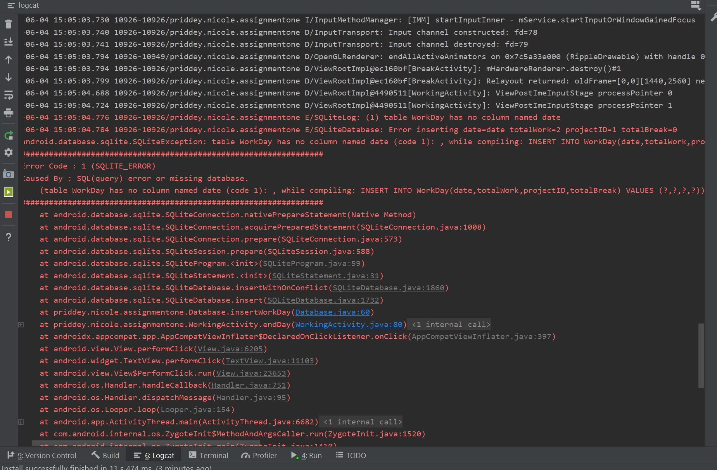 Changed the date I add to read the error message better

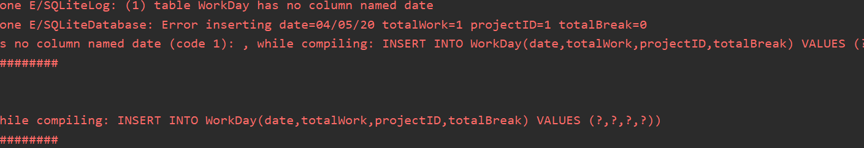 Looks like the columns are in the wrong order

Appears to not be creating the table. This website mentioned deleting the database file. (Table not getting created sqlite android, n.d.) Which fixed it.

Showing up blank I’m unsure if the error is with inserting or retrieving

(View on-device files with Device File Explorer, n.d.)looking at where to find the database file but can’t read it.

Trying to figure out how to install sql lite to read the file (How To Download & Install SQLite Tools, n.d.)

The issue was spacing in the creation of the table

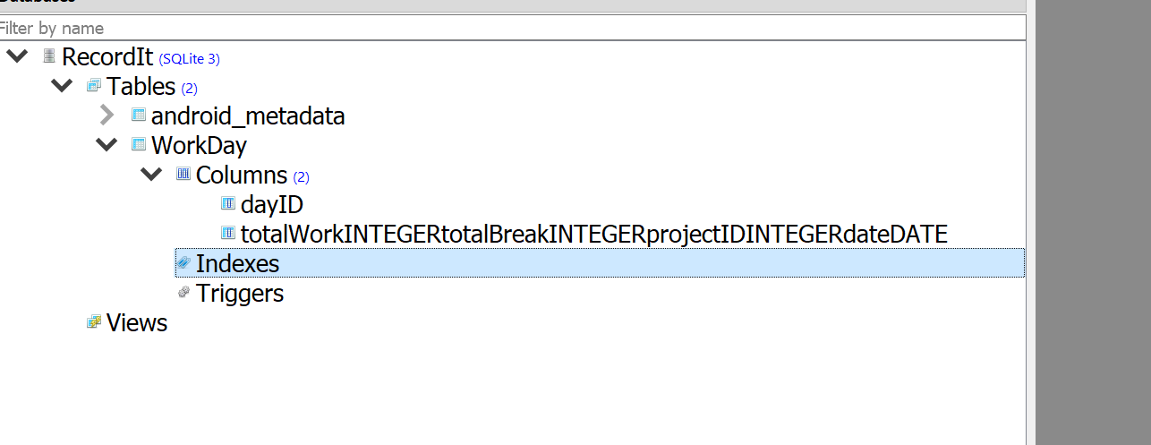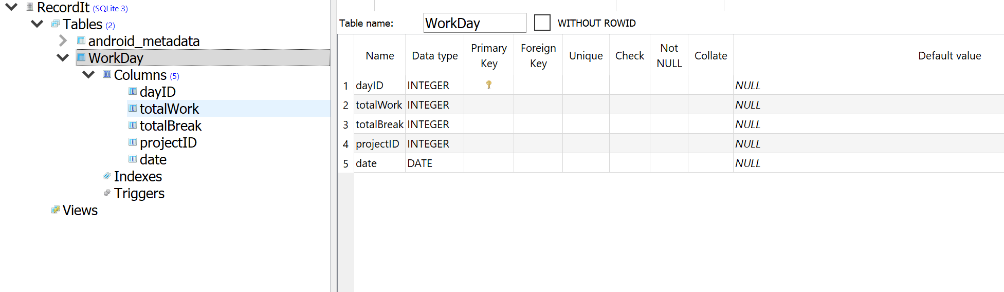

The table now creates and enters the data but the app crashes

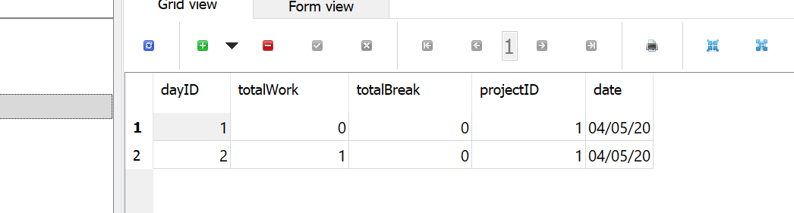

Added debug messages to see what is causing the crash

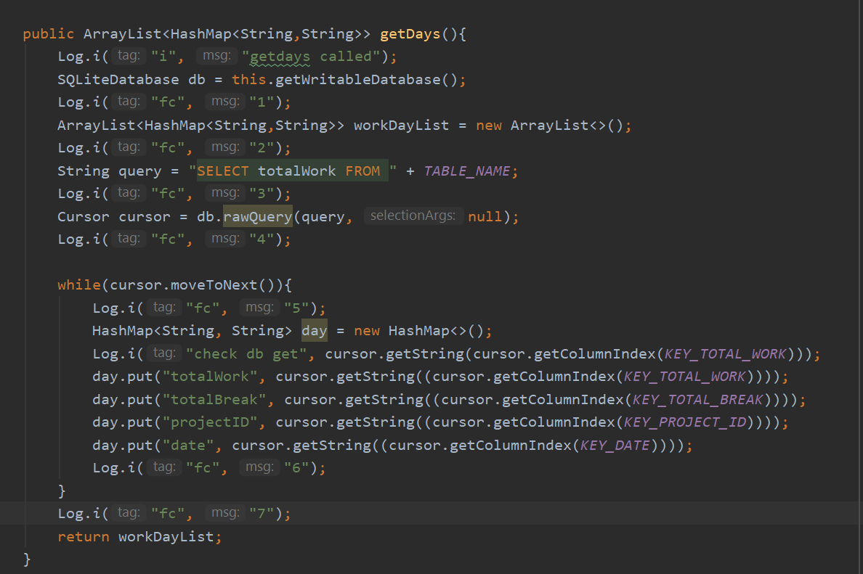

After 3 and before 4 is causing the crash so the Cursor creation is breaking it this could be the sql query

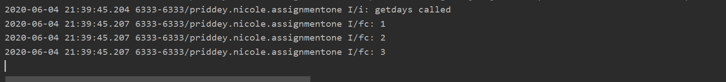

Query appears to be fine

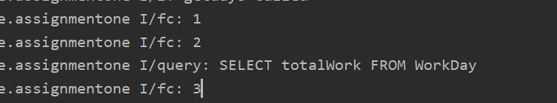

Doesn’t crash now but still does not show anything. Since it does not go into the loop it looks like the cursor is empty

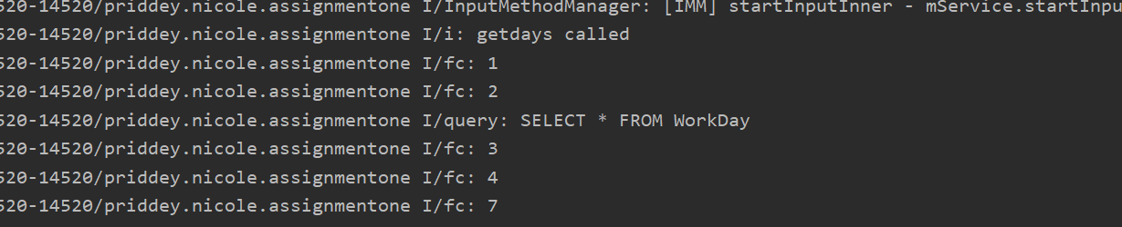

Found how to confirm if the cursor is empty from (How To Test If Cursor Is Empty in a SQLiteDatabase Query, n.d.) Confirmed cursor is empty

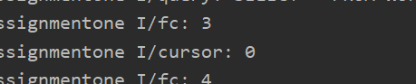

The cursor isn’t actually empty just needed to uninstall and reset the database

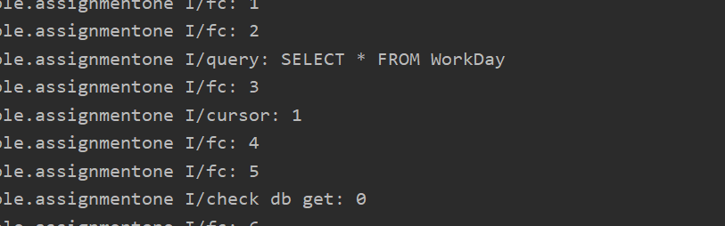

Realized I was not adding the day to the workdayList, added it but now it crashes again.

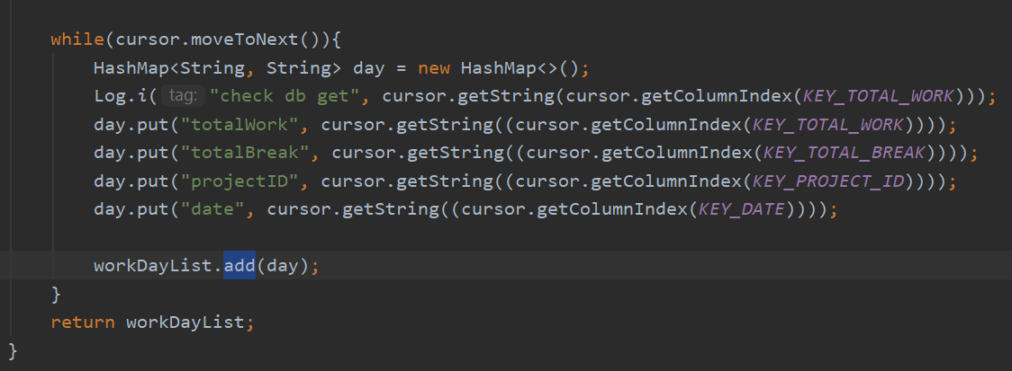

The summary page is getting the database info in the HashMap

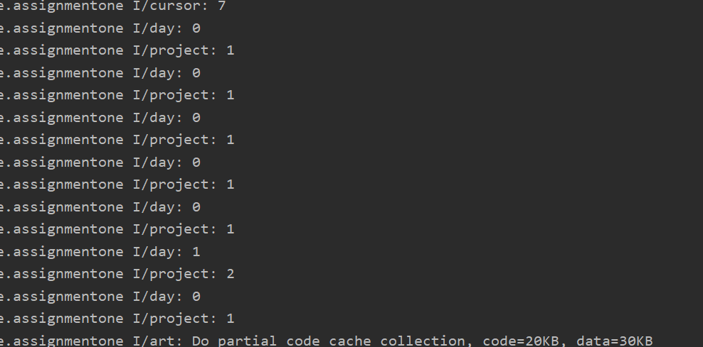

All the bits are running bit it still crashes. The lab video I’m following did have an error in it that I don’t know what the solution was so it may be that.

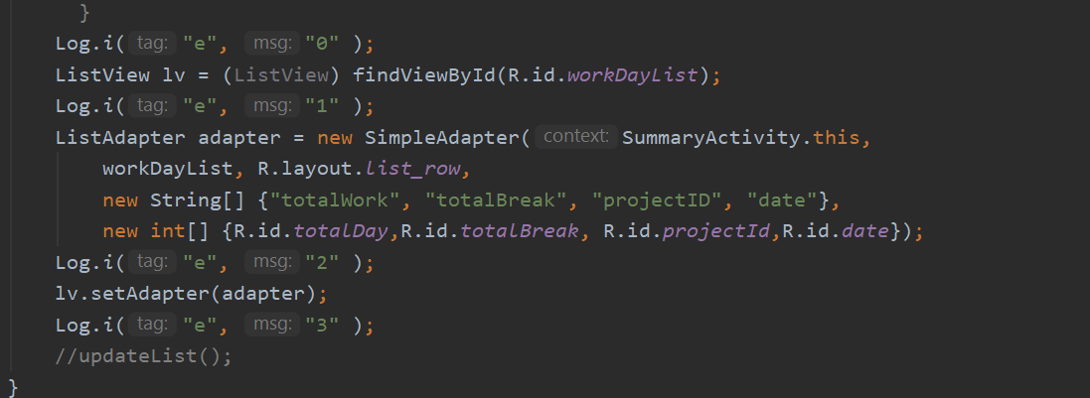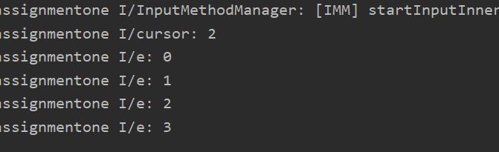

All the data is getting put into the hashmap the adaptor must not be working correctly. Reading about simple adaptors here: (SimpleAdapter, n.d.), (Listview to SimpleAdapter not working, n.d.)

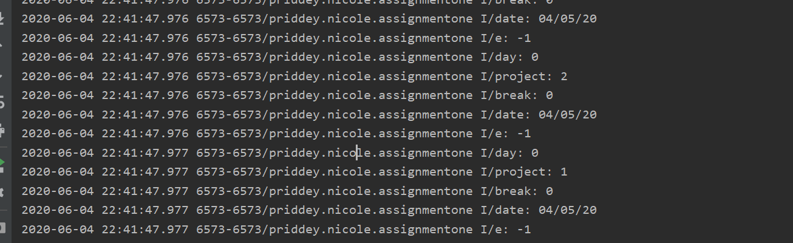

I change it so I only get two pieces of data from the database and this appeared to work. This site indirectly gave me the idea: (Using an ArrayAdapter with ListView, n.d.). Im uncertain why but it might have something to do with the adaptor and the lists I give it. I will need to modify it so it can get all the information.

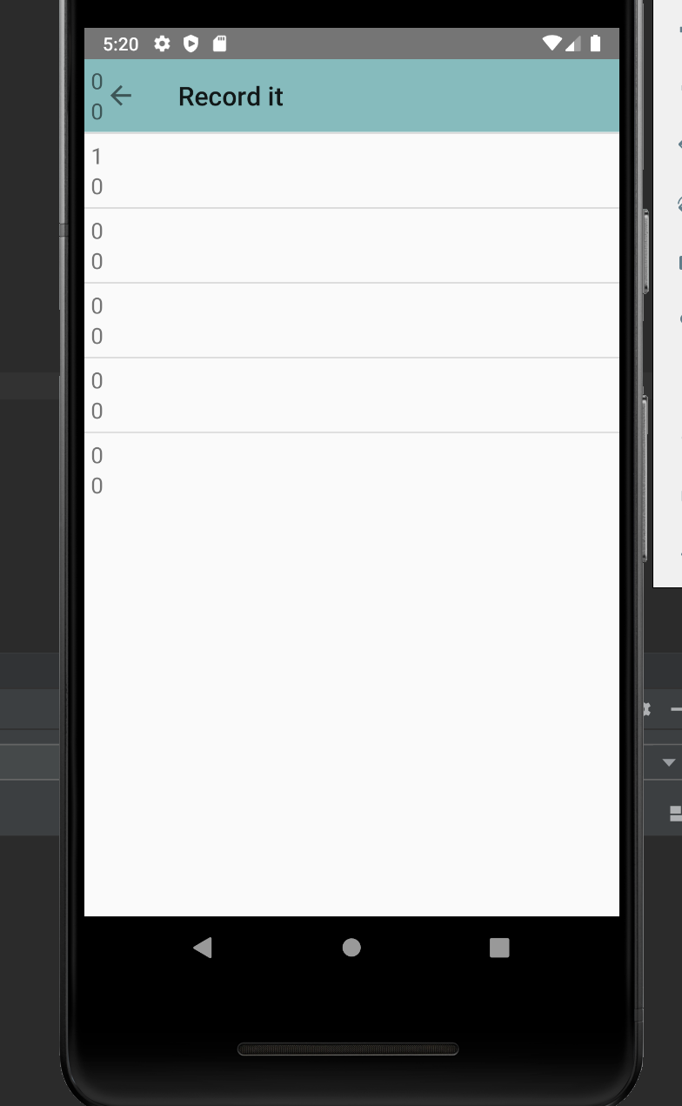

## Fragments and app bar

I tried to implement adding a fragments and a bottom navigation bar by following this tutorial. (Bottom Navigation Bar Android Example, n.d.)

Adding fragments, the code has no errors but its not working currently. Im unsure what is it opening. Upon further looking it’s the first of the setting options and I missed two of the styling bits.

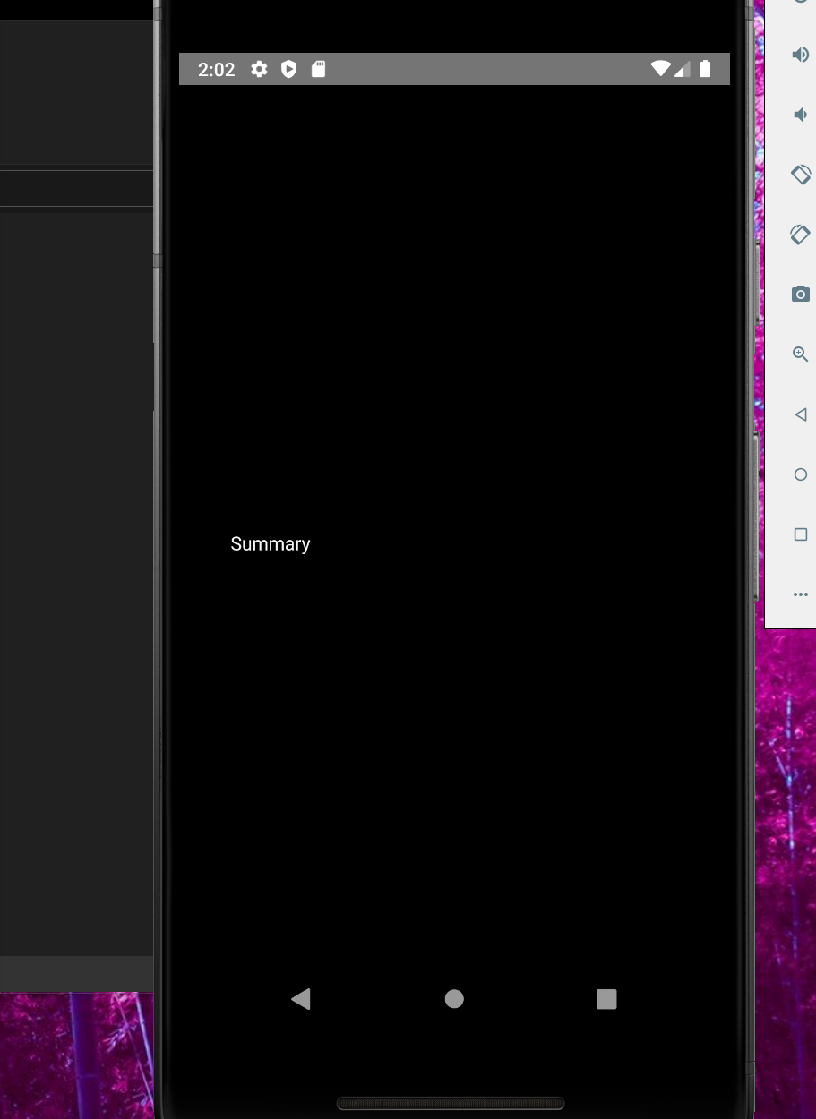 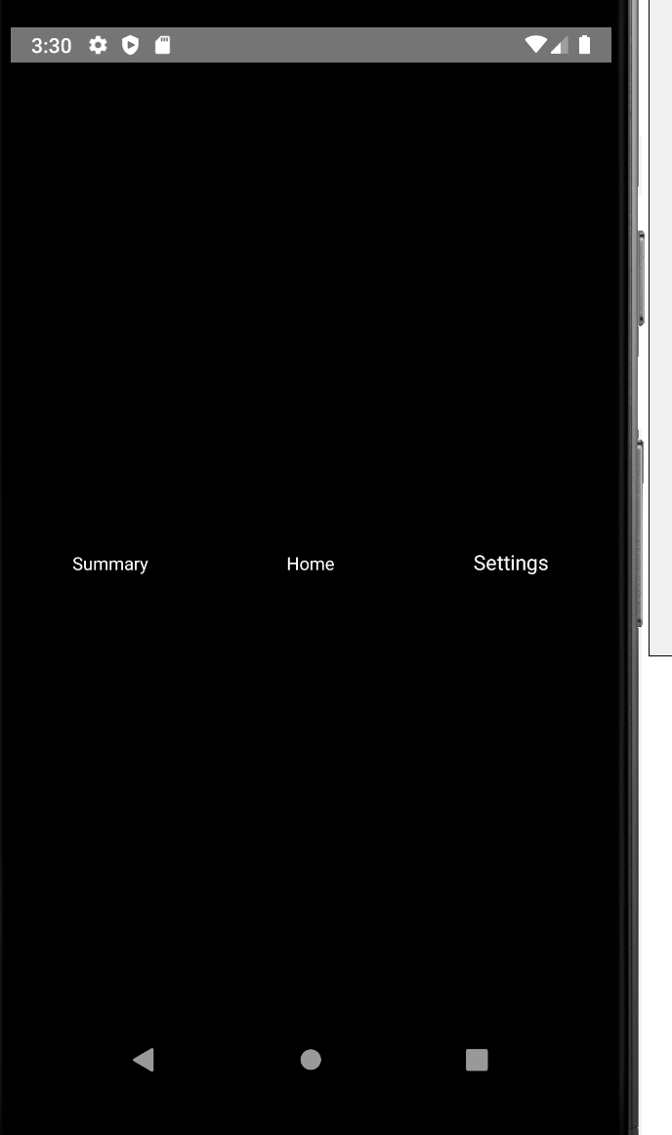

It now Selects the different items but it does not open the fragment.

I started a new project with a bottom navigation that works but with out the database working it will be difficult to keep track of the workday object.

Looking at finding views with fragments: (java.lang.NullPointerException: Attempt to invoke virtual method 'android.view.View android.app.Activity.findViewById(int)' on a null object reference, n.d.) and (findViewById in Fragment, n.d.)

Discarded this for the time being and continued with the activities.

## Other features

I added a delete button to the summary page and wanted to know how to reload the activity. This page told me how (Reload activity in Android, n.d.)

The back button is no longer working on the summary page even though the code is still there and should be working. This will be fixed in the final project when the bottom navigation is implemented.

### Final Project

I added a bottom navigation, I used these to help me: (Best Java code snippets using com.google.android.material.bottomnavigation.BottomNavigationView.setOnNavigationItemSelectedListener, n.d.), (CodingWithMitch, Designing ToolBars [App Bar Material Design] - Android Advanced Tutorial #3, n.d.), and (CodingWithMitch, Bottom Navigation Bar with Activities - Android Advanced Tutorial #6, n.d.) (Bottom Navigation Bar with Activities - Android Advanced Tutorial #6, n.d.). I want to use activities instead of fragments. I just added the bottom nav to each activity which works but it makes a new one each time and doesn’t keep track of which one is selected. So I used this video: (Bottom Navigation Bar with Activities - Android Advanced Tutorial #6, n.d.)from around 14:40 to help me make it show the selected item.

I wanted to add a drop down for the user to select the project from. This page: (Spinners, n.d.) told me what that is called. And this page I used to help implement it (How can I add items to a spinner in Android?, n.d.)

Next I wanted to add fragments to the working activity for the working and break pages. (Create a fragment, n.d.), I tried this site but it was not working so I found a more detailed example (Fragment Tutorial With Example In Android Studio, n.d.) which is now working.

Having the default import import androidx.fragment.app.Fragment; wouldn’t work with that tutorial so I had to change it to import android.app.Fragment;

I added in the buttons and text from the last part and it made the app crash. I commented some out and it still crashed so I looked at the logcat to find where the error was and it was with the findViewById in the fragments

(Android center view in FrameLayout doesn't work, n.d.) and (findViewById in Fragment, n.d.) these didn’t help so I went back and looked at the first one (Fragment Tutorial With Example In Android Studio, n.d.) and that had view.findViewById after the inflater

Looking at how to close a fragment and open a new activity. (Button to Open New Activity from fragment, n.d.) and (Finishing current activity from a fragment, n.d.)

The buttons weren’t working with the onclick being defined in the xml so I looked at this one (Fragment Tutorial With Example In Android Studio, n.d.) again and created the onclick in the java which is now working

I added the database code from the 2nd assignment and need to check it works. The spacing is out, so need to fix the layout.

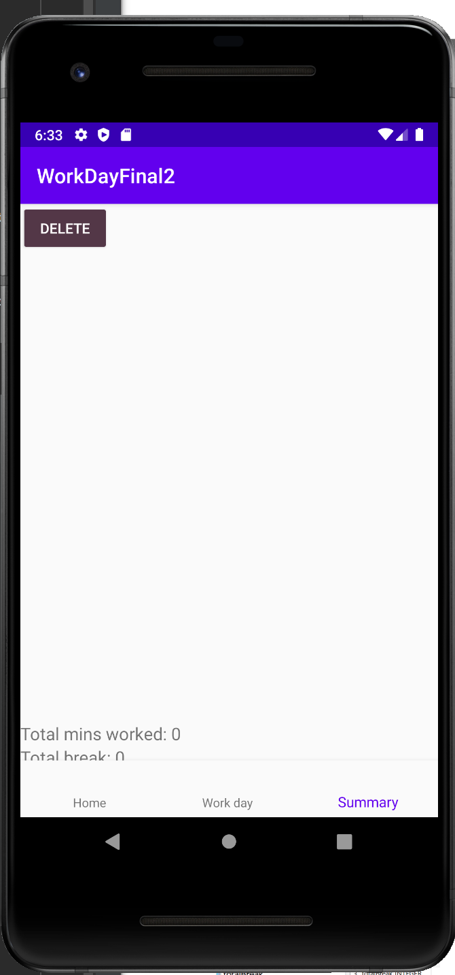

The list wasn’t laid our correctly. Its still not fully correct but it is better

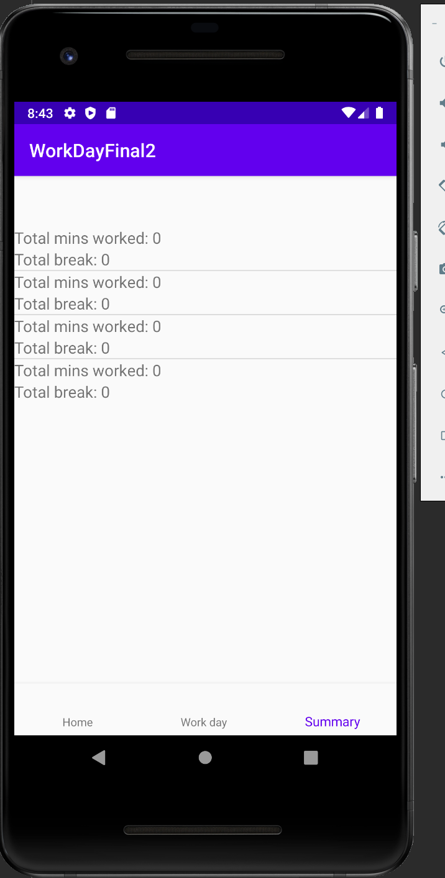

Moving the button didn’t help

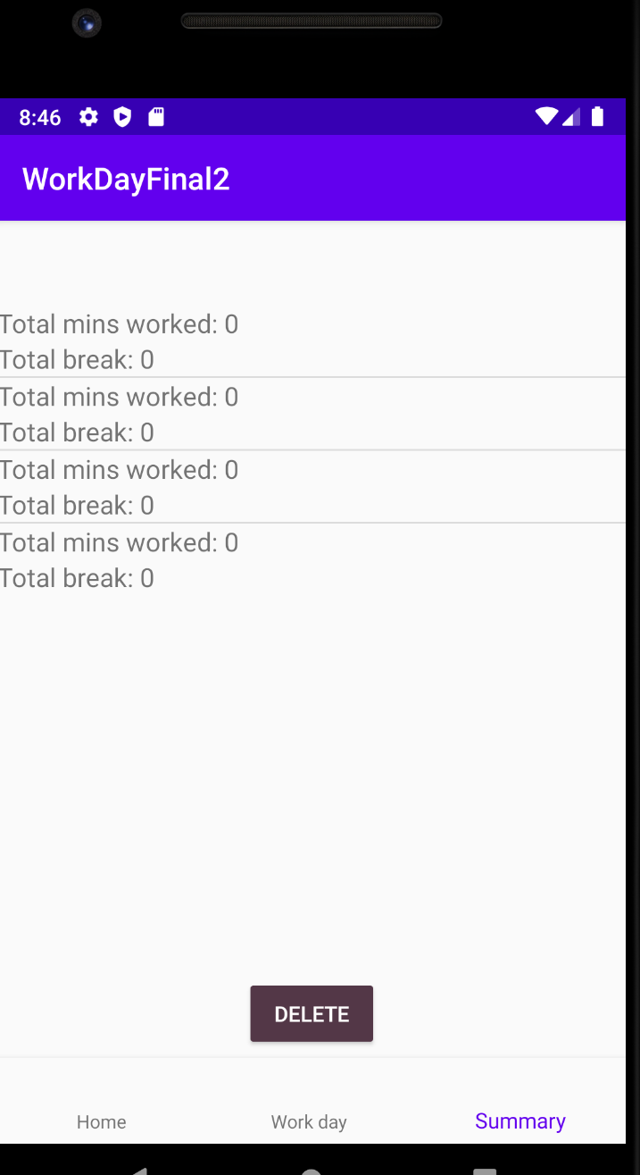

It had padding top in the xml which was needed for the menu bar but not here

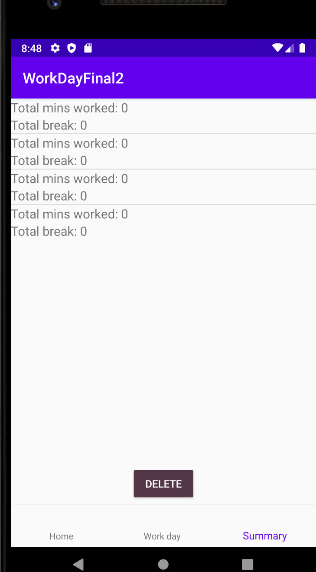

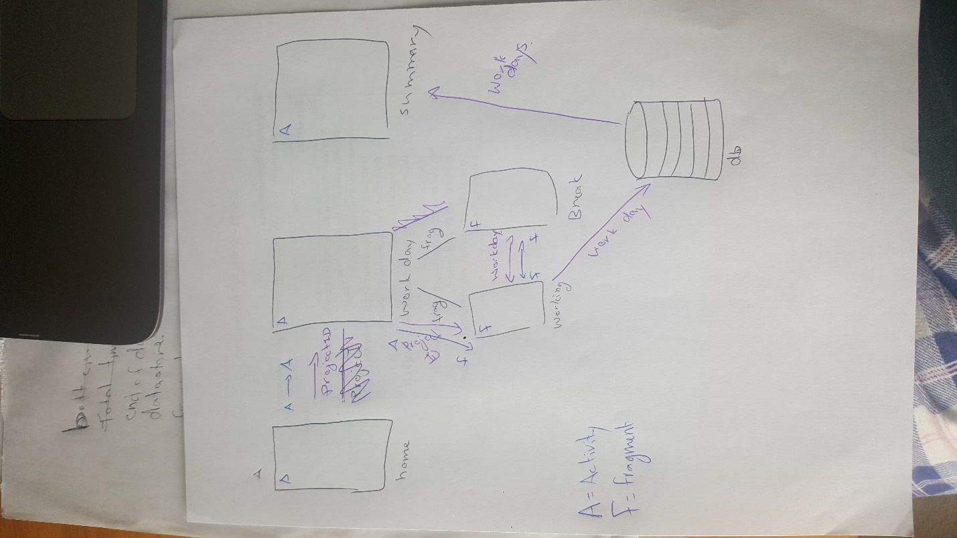

Figure - Sketch of communication throughout the app

Next I need to pass the data between fragments. (Pass data between fragments, n.d.). I find this source difficult to use so I look for a more full example (How to pass values between Fragments, n.d.), the first answer isn’t fully helpful but the second on is. (How to pass values between Fragments, n.d.) this link made it clear that I needed to create my own interface. This is confusing so I decided to watch a video to understand better. (YouAreCoder, n.d.) This video uses bundles to pass data between fragments. This feature appears to be depreciated but it works and is less confusing then the other method.

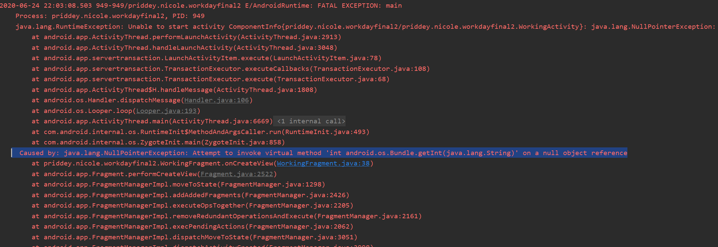

Error when running. Realized it was code from my first attempt that was causing this, removed it opened this fragment with no errors.

Data successfully passed between the two fragments.

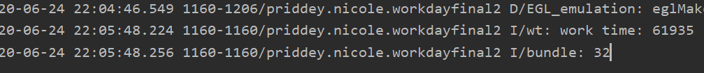

Data passing one way appears to be working, need to implement the other was to test properly.

Error as expected for null value when there is no argument the first time. Added an if statement to check if the bundle is null.

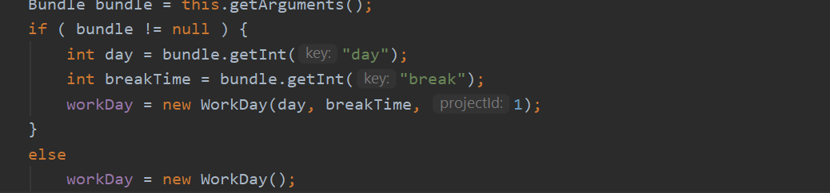

Break time is communicated from break fragment to working fragment then stored in db and retrieved and displayed in the summary page

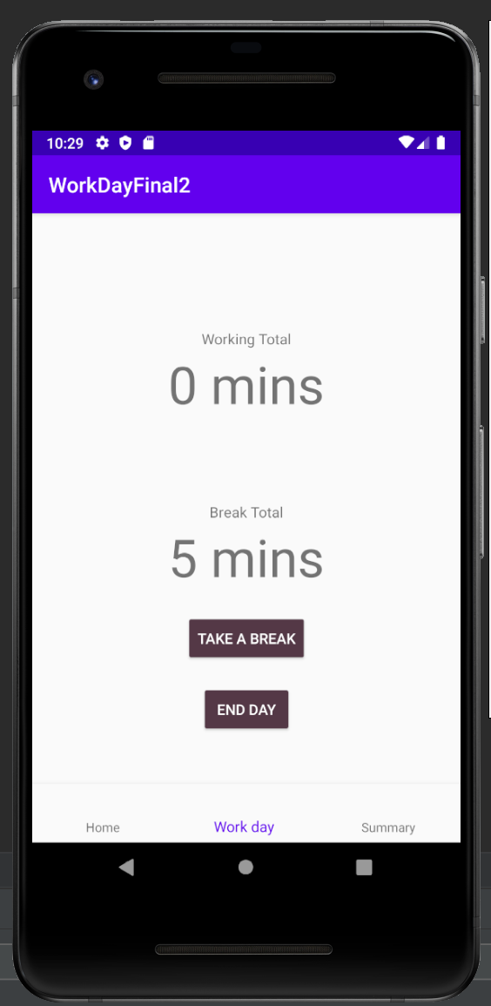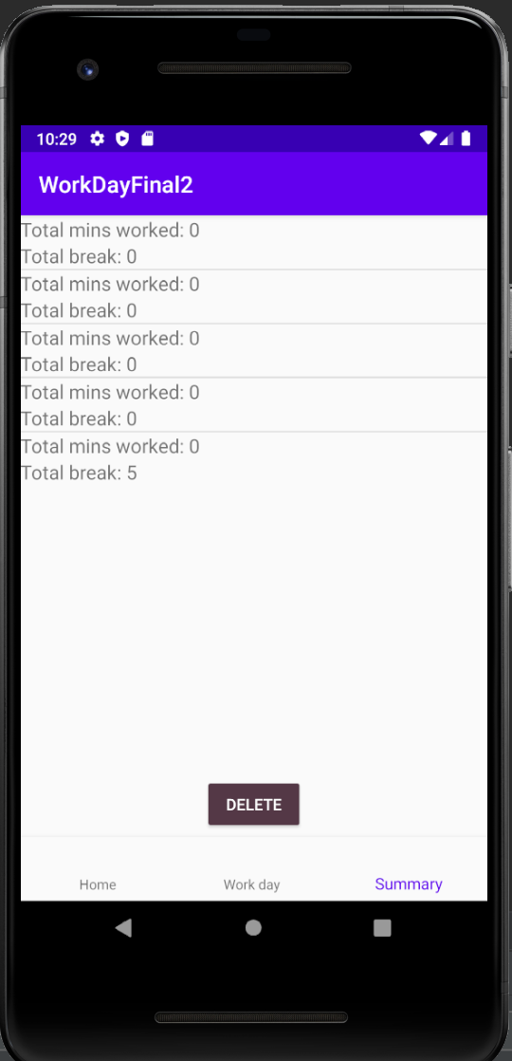

Now I need to pass information from the first activity through the second one to the first fragment.

To do this I used part of the first answer from this link (How to pass values between Fragments, n.d.)

This was the same method I used to pass the WorkDay object in the first and second assignment.

Need to figure out if I need logic in the working fragment to differentiate between projected bundle and break bundle. Appears to be passing the data between activities and fragments correctly.

Looking at how to add the timer (Update a textView in real time (using a for), n.d.). Seemed like it would be helpful but it did not have enough of the done to know where to put it/get it to work. (how to change text in Android TextView, n.d.)same issue as above did not know where to put code

Im thinking I will need to change the method of doing this and add a timer (How to display the timer in android, n.d.)

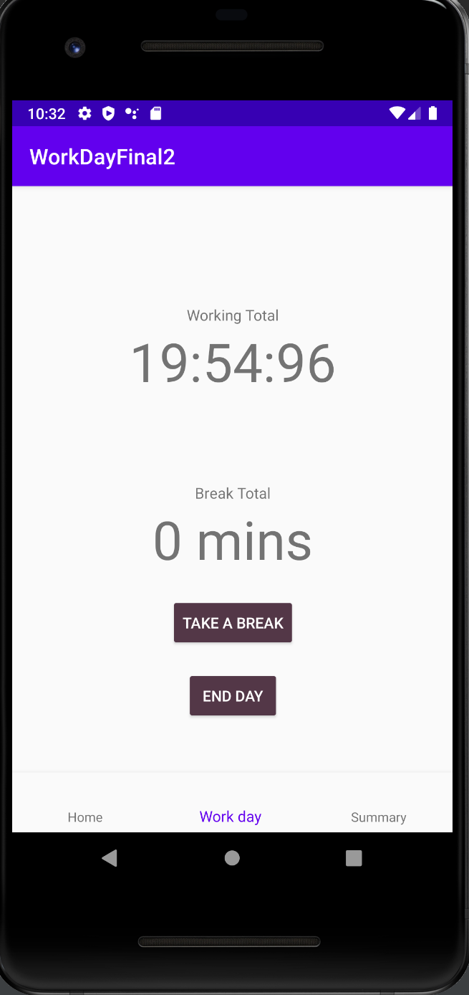

Has a timer that is updating but it is counting down and still allows to click the buttons. Modify the code to count up. (How to add a Countup timer on Android?, n.d.) followed that link in the first answer to (MiguelLavigne/CountUpTimer.java, n.d.)

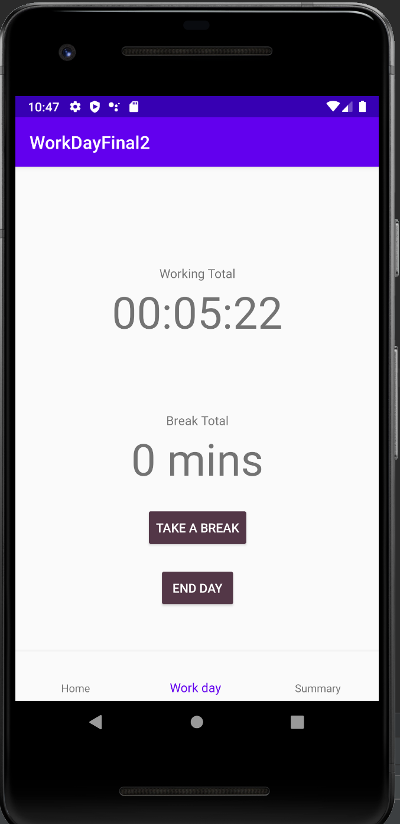

Timer is counting up in seconds. Need to change it to minutes and try and start the base in the timer from what the current total.

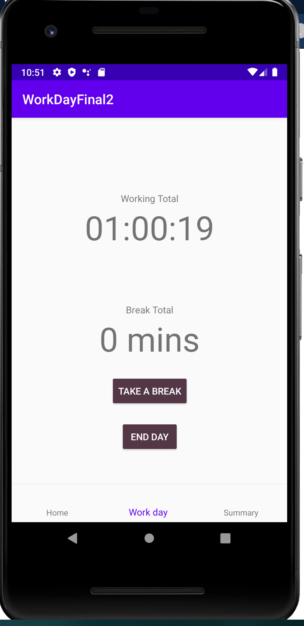

Changed the timer to use 60000 milli second interval which is a minute

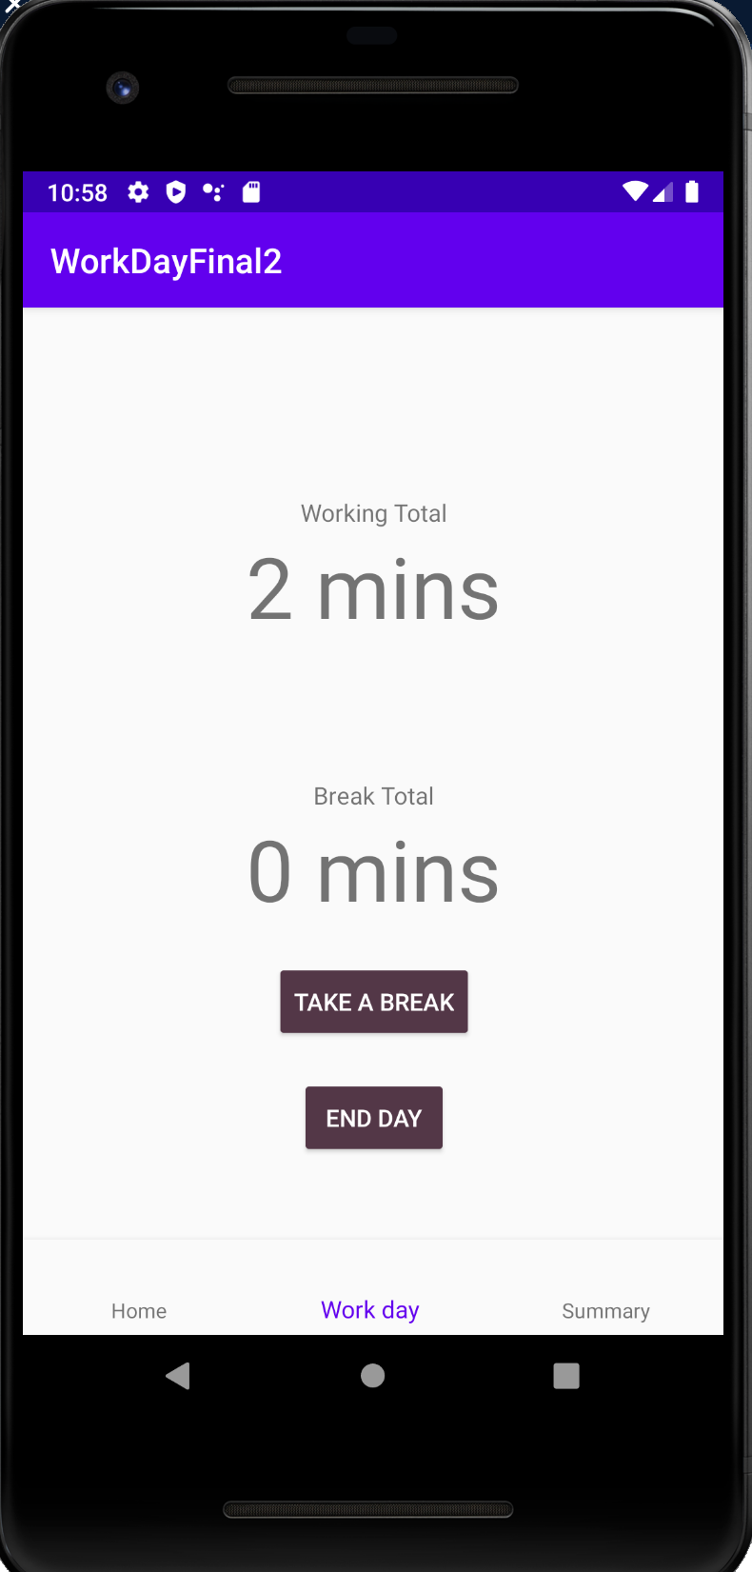

Displays it in minutes, just need to make sure it starts from what the total time actually is because clicking buttons resets it.

Modified the code to make sure the time is being set in workday, It is passing to end day but not coming back from the break. Two things to check if it is the passing to break that is not working or if it is the getting the data back that isn’t.

When I modified the code so that total day and break were long instead of int I didn’t change the types when getting the info out of the bundle in the working activity. This didn’t actually throw errors which is why I missed it. This fixed the issue.

Its working for the working total now I need to do the same with the break total on the break page. This worked.

While testing I noticed I realized having minutes over 60 was not the easiest to read so I added some logic to make this into hours if it is over 60 min.

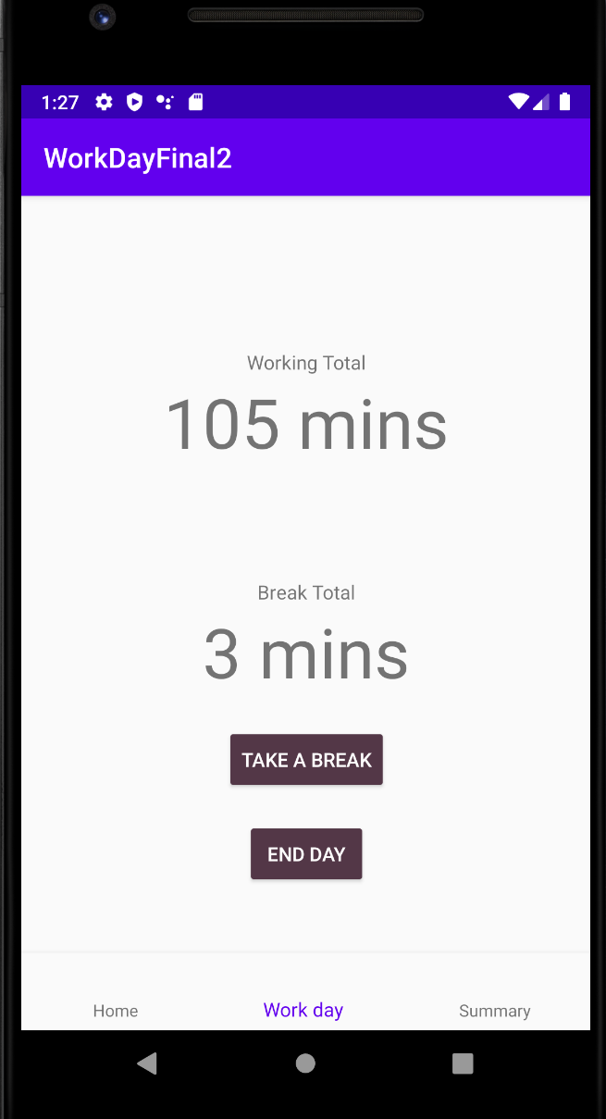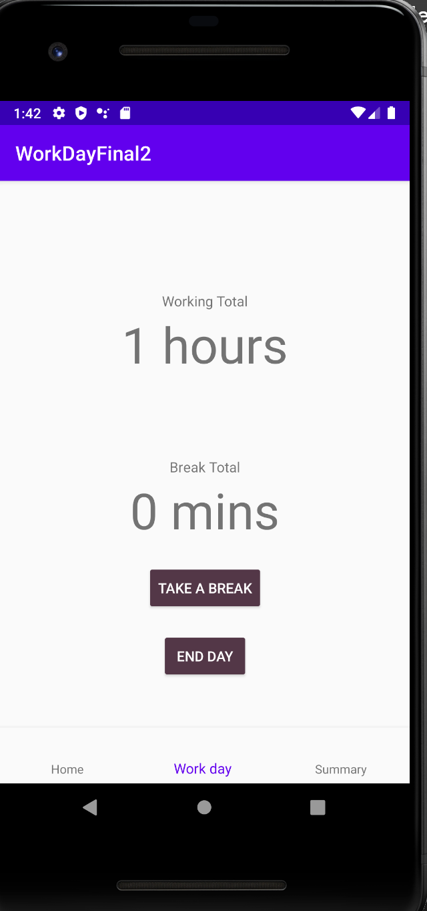

I also noticed in the summary page that it is showing the break in seconds still even though I have code to convert it. I think It was just not reloading properly because now it is working.

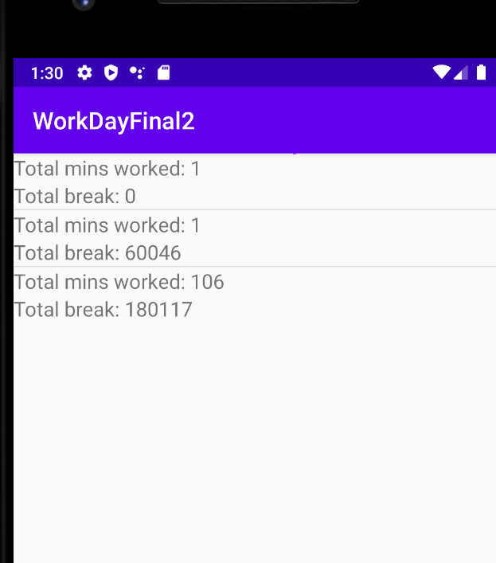

I also noticed that the time on the working total was not incrementing by one. My issues was that I was adding that total timer each time to the total day not just the new number. I changed a couple things around and it stopped it from updating all together. Modified it again and now it is updating correctly.

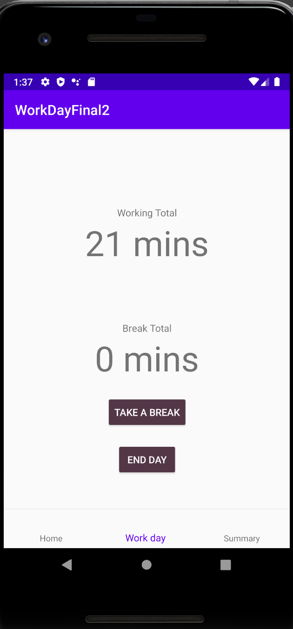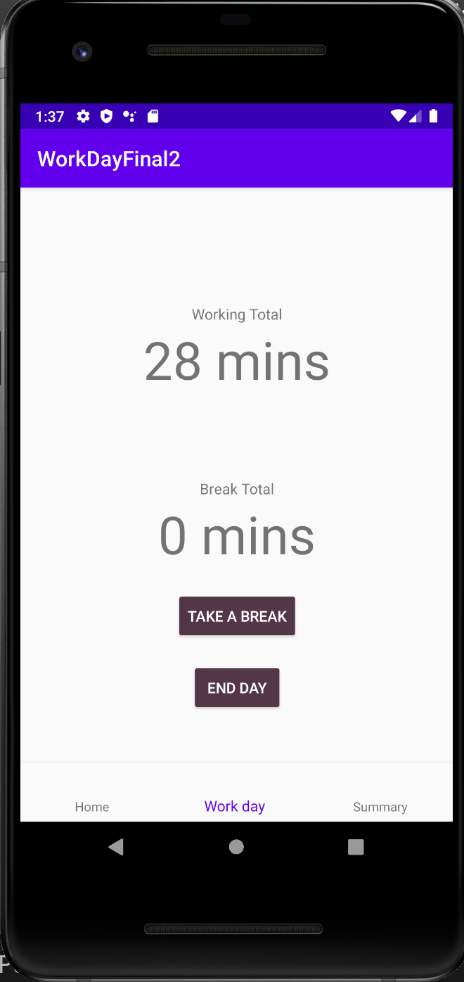

Next I added the custom app bar so I can change the headings on each page. Adding this broke the navigation highlight so it is now white and you cant see it. And also the heading isn’t setting correctly. The heading was an error in the code. I was seating the id for the second assignment to one instead of 2.

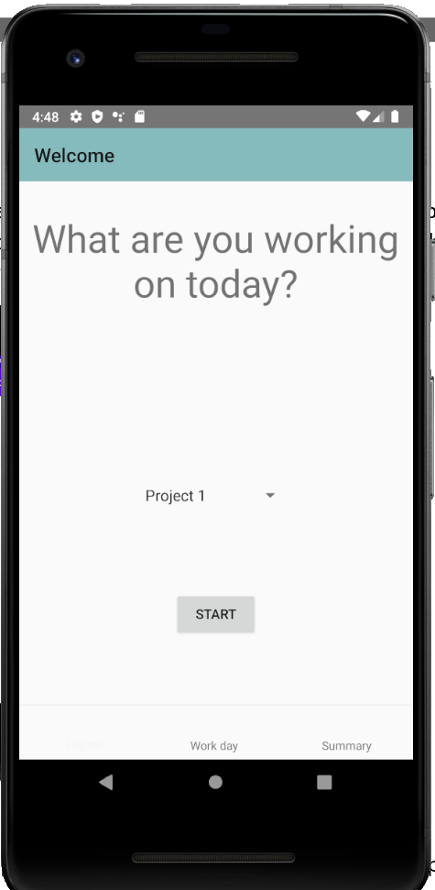

(Selected tab's color in Bottom Navigation View, n.d.), (How to change the text and icon color of selected menu item on Navigation Drawer programmatically using java, n.d.) and (Change the color of a checked menu item in a navigation drawer, n.d.) both had suggestions for a selector, which I didn’t not know where to put. The first suggested adding a style and setting the theme for the bottom nav which worked.

Order the summary page so it shows the news entries first, needed to add the current date. (How to get current time and date in Android, n.d.)

Finally went through the code and made sure there were no redundant pieces, no log statements left and suggestions from the IDE were considered. Made sure all the strings were in the resource file and not hard coded to make localization easier.

When generating the APK I generated the debug one which worked and installed correctly, Then I made the release unsigned one which was apparently corrupt, 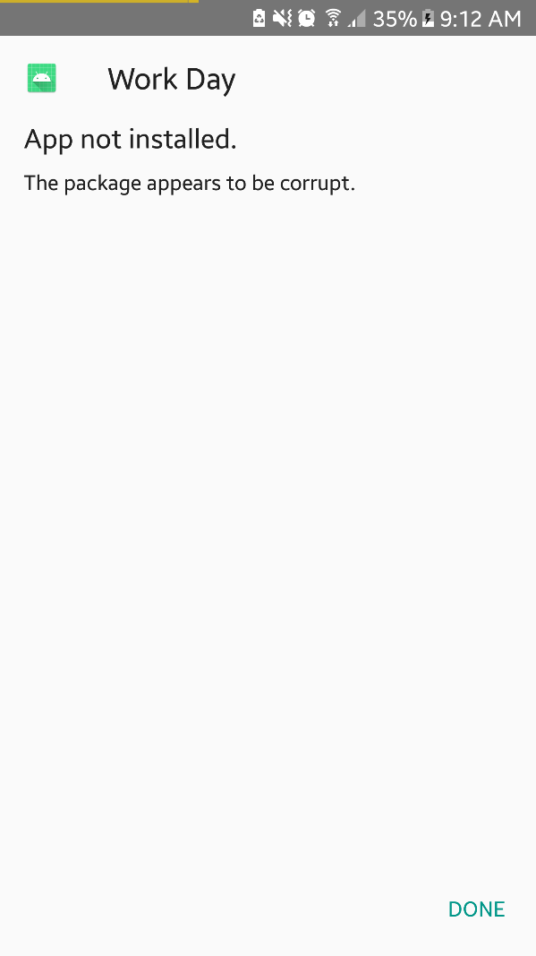 so I looked at making a signed one 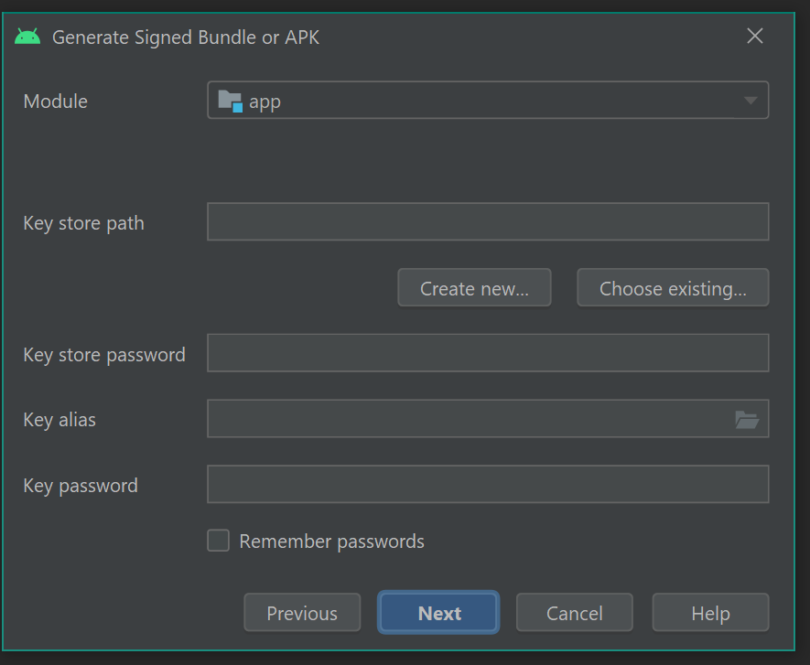 But I don’t have a developer account on the play store so I don’t have the key information needed to do this. The only apk that works is the debug one.

# Testing

Assignment 2

I didn’t really have method that returned a value that I could check for the unit test so I modified one of my methods so there was one.

Test case:

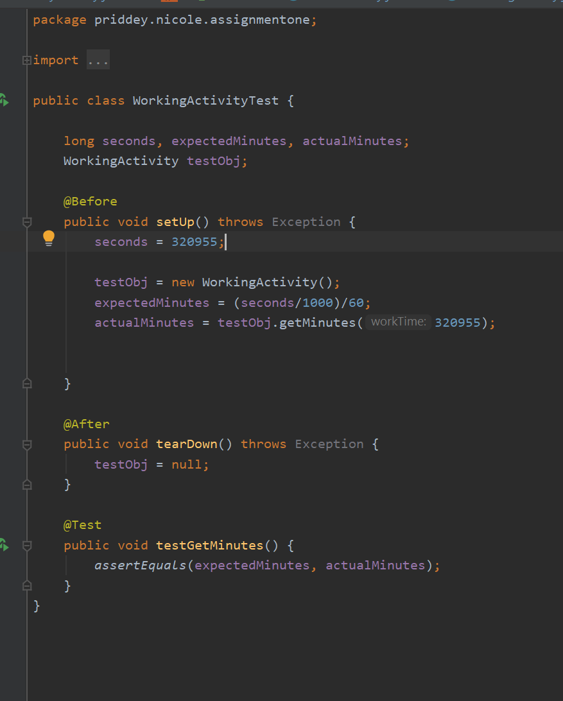

Test outcome: success

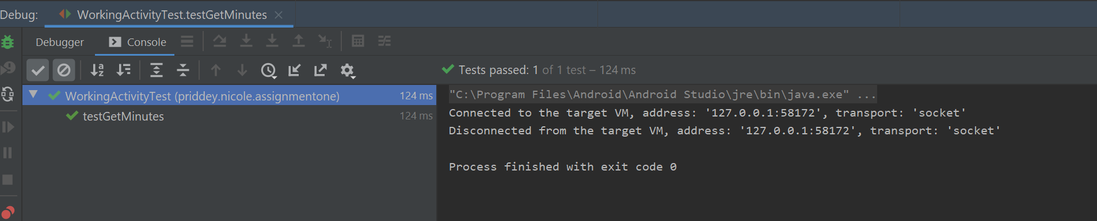

Final Project

Looking into using espresso: (Espresso, n.d.), (Android user interface testing with Espresso - Tutorial, n.d.), (Create UI tests with Espresso Test Recorder, n.d.)

Tests performed on an emulator and a physical device of different sizes.

#### Interface testing to make sure all buttons work/text updates

|  |  |  |  |  |
| --- | --- | --- | --- | --- |
| Button/Text to test | Page | Expected outcome | Actual outcome | Changes |
| Start btn | Home activity | Navigate to work day activity opening working fragment | As expected | N/A |
| Spinner | Home activity | Allows to select from list, selected item is used in the work day activity app bar. | As expected | N/A |
| Work day | Home Nav bar | Navigate to work day activity opening working fragment | As expected | N/A |
| Summary | Home Nav bar | Navigate to summary activity | As expected | N/A |
| Project name | Workday activity | Item selected on home page spinner is displayed | As expected, default is first item | N/A |
| Take a break btn | Working Fragment | Open break fragment | As expected | N/A |
| End day btn | Working Fragment | Add work day information to database and open summary page | As expected | N/A |
| Working total txt | Working Fragment | Updates every minute | As expected | N/A |
| Break Total txt | Working Fragment | Updates after break ends | Not updating |  |
| Break length txt | Break Fragment | Updates every minute | As expected | N/A |
| Back to work btn | Break Fragment | Navigate back to working fragment, updating break total | Navigates correctly but does not update text |  |
| Delete btn | Summary activity | Deletes data from database | As expected | N/A |
| list | Summary activity | Display list with the total times and break times. | As expected | N/A |
| Home | Work day Nav bar | Navigate to home activity | As expected | N/A |
| Summary | Work day Nav bar | Navigate to summary activity | As expected | N/A |
| Home | Summary Nav bar | Navigate to home activity | As expected | N/A |
| Work day | Summary Nav bar | Navigate to work day activity opening working fragment | As expected | N/A |

#### User acceptance testing

|  |  |  |
| --- | --- | --- |
| Section | Comments | Changes made |
| Navigation | Navigation works, but the animation switching between them is not right. Also there could be icons on the nav bar | None, added to future improvements. |
| Colours | Over all colours are good except on the nav bar the selected colour is too bright to match | Nav bar selected colour updated to match button colour |
| Home | Main text is too big compared to button and spinner text. Alignment is a bit off. App bar says “hello” which seem incorrect | Main text made smaller, and moved start button slightly lower. App bar changed to home |
| Work day | Buttons may be too high but the test size is good. On real device the items are too far left. | Buttons lowered and lined up next to each other. |
| Summary | Bit hard to read and could do with better spacing, list goes off the end of the screen. | Spacing improved and text size increased. Bottom of list aligned to top of nav bar |

# Screenshots of the app

Assignment 1

Figure 2. Home page displays a greeting and the buttons for the two different projects that go to the working page.

Figure 3. Home page with the menu expanded. Summary and settings lead to their respective pages

Figure 4. Summary page.

Figure 5. Settings page. Currently blank but will be implemented in the next iteration

Figure 6. Working page. Has the project name in the Toolbar. Take a break and end day buttons goes to the break and summary page respectively

Figure 7. Break page. Has the project name in the Toolbar. Back to work button goes back to the working page.

Changed screens in assignment 2:

Figure . Summary page displaying records from the database

Figure . Records deleted and activity refreshed after delete pressed

Figure . Adding records after delete

Figure . Adding multiple records

### Final Project

The below screenshots highlight the changed features in this assignment.

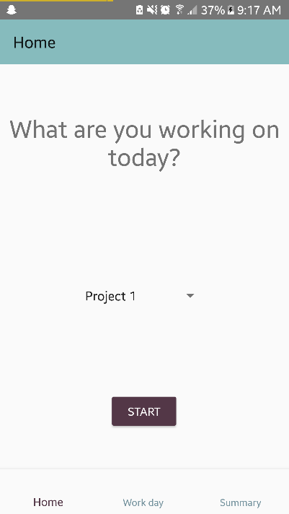

Figure - Added a bottom navigation

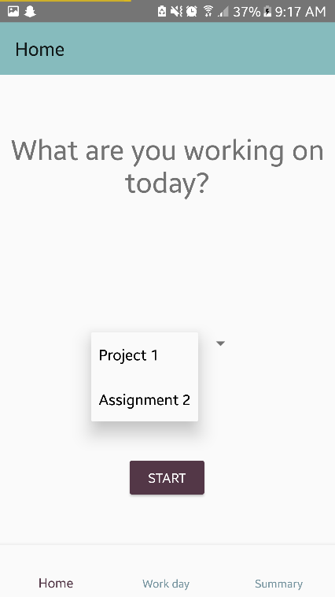

Figure - Have a spinner to select which project to work on

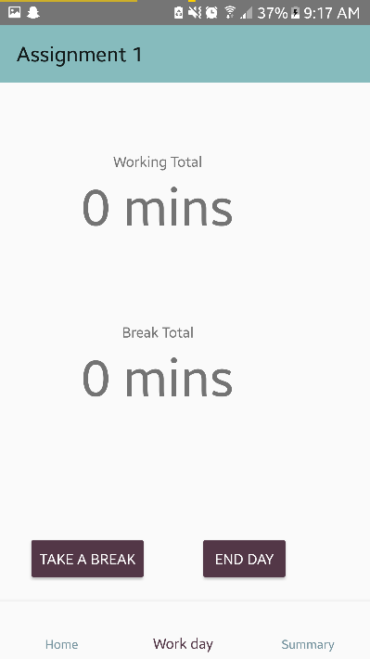

Figure - buttons aligned next to each other and working total counts up

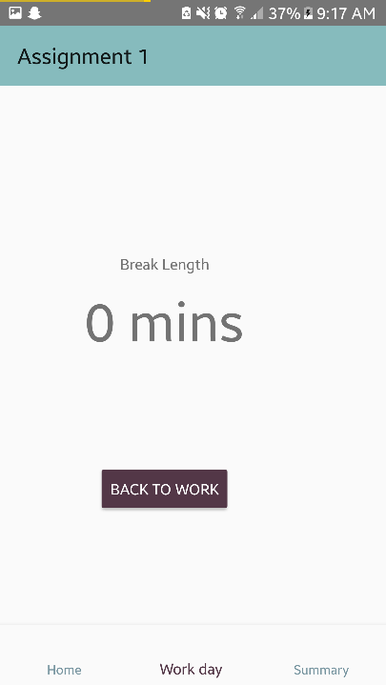

Figure - Nothing physically changes but the timer now counts up in real time

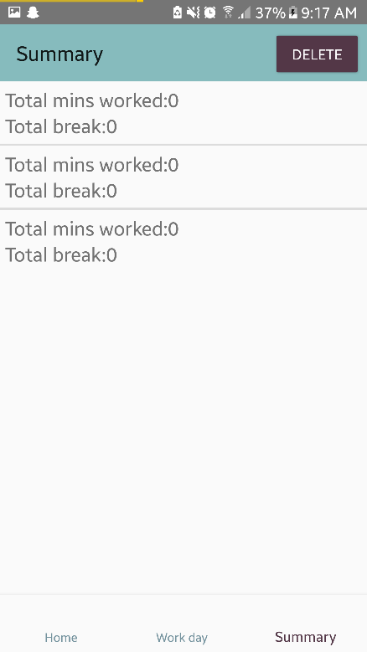

Figure - newest at the top and padding/text sized changed for readability

# Summary and recommendations.

I think my idea worked well for this project, I was something I had planned out in Human Interface Tech class and now get to put into development. I had the ability to add many features and could sill add many more. I think the agile methodology of development was good because each assignment I could have an app that had some working features but didn’t need them all. This was good because I didn’t need to get everything working at once and I was able to change my design as I went and found a way that looked better/was easier to use.

During this project I found that the languages were well documented, and I was able to find a lot of information on them. I found looking at the documentation for android developer was not the best as it didn’t really show it in use, but this might be better once I am more familiar with the lifecycles and how android works.

After this project is handed in, I plan to continue development and finish of this app fully and learn how to properly test it using automated tools.

Recommendations for future students

* Use an agile style methodology
* Have a project that you can add many features to and focus on a couple for each assignment rather than getting them all to work at once
* Allow time for things to not work as you expected
* Follow tutorials online

# References

*Android center view in FrameLayout doesn't work*. (n.d.). Retrieved from stackoverflow: https://stackoverflow.com/questions/4051604/android-center-view-in-framelayout-doesnt-work

*Android user interface testing with Espresso - Tutorial*. (n.d.). Retrieved from vogella: https://www.vogella.com/tutorials/AndroidTestingEspresso/article.html

*AUTOINCREMENT is only allowed on an INTEGER PRIMARY KEY - android*. (n.d.). Retrieved from stackoverflow: https://stackoverflow.com/questions/25562508/autoincrement-is-only-allowed-on-an-integer-primary-key-android

*Best Java code snippets using com.google.android.material.bottomnavigation.BottomNavigationView.setOnNavigationItemSelectedListener*. (n.d.). Retrieved from codota: https://www.codota.com/code/java/methods/com.google.android.material.bottomnavigation.BottomNavigationView/setOnNavigationItemSelectedListener

*Bottom Navigation Bar Android Example*. (n.d.). Retrieved from androidwave: https://androidwave.com/bottom-navigation-bar-android-example/

*Bottom Navigation Bar with Activities - Android Advanced Tutorial #6*. (n.d.). Retrieved from Youtube: https://www.youtube.com/watch?v=xyGrdOqseuw

*Button to Open New Activity from fragment*. (n.d.). Retrieved from c-sharpcorner: https://www.c-sharpcorner.com/forums/button-to-open-new-activity-from-fragment

*Change the color of a checked menu item in a navigation drawer*. (n.d.). Retrieved from stackoverflow: https://stackoverflow.com/questions/30886453/change-the-color-of-a-checked-menu-item-in-a-navigation-drawer

CodingWithMitch. (n.d.). *Bottom Navigation Bar with Activities - Android Advanced Tutorial #6*. Retrieved from Youtube: https://www.youtube.com/watch?v=xyGrdOqseuw

CodingWithMitch. (n.d.). *Designing ToolBars [App Bar Material Design] - Android Advanced Tutorial #3*. Retrieved from Youtube: https://www.youtube.com/watch?v=_FWeURCpkdE

*Create a fragment*. (n.d.). Retrieved from developer.android.com: https://developer.android.com/training/basics/fragments/creating

*Create UI tests with Espresso Test Recorder*. (n.d.). Retrieved from developer.android.com: https://developer.android.com/studio/test/espresso-test-recorder

*Espresso*. (n.d.). Retrieved from developer.android.com: https://developer.android.com/training/testing/espresso

*findViewById in Fragment*. (n.d.). Retrieved from stackoverflow: https://stackoverflow.com/questions/6495898/findviewbyid-in-fragment

*findViewById in Fragment*. (n.d.). Retrieved from stackoverflow: https://stackoverflow.com/questions/6495898/findviewbyid-in-fragment

*Finishing current activity from a fragment*. (n.d.). Retrieved from stackoverflow: https://stackoverflow.com/questions/7907900/finishing-current-activity-from-a-fragment

*Fragment Tutorial With Example In Android Studio*. (n.d.). Retrieved from abhiandroid: https://abhiandroid.com/ui/fragment

*How can I add items to a spinner in Android?* (n.d.). Retrieved from tutorialspoint: https://www.tutorialspoint.com/how-can-i-add-items-to-a-spinner-in-android

*How to add a Countup timer on Android?* (n.d.). Retrieved from stackoverflow: https://stackoverflow.com/questions/9276858/how-to-add-a-countup-timer-on-android

*how to change text in Android TextView*. (n.d.). Retrieved from stackoverflow: https://stackoverflow.com/questions/2300169/how-to-change-text-in-android-textview

*How to change the text and icon color of selected menu item on Navigation Drawer programmatically using java*. (n.d.). Retrieved from stackoverflow: https://stackoverflow.com/questions/42700908/how-to-change-the-text-and-icon-color-of-selected-menu-item-on-navigation-drawer?rq=1

*How to display the timer in android*. (n.d.). Retrieved from stackoverflow: https://stackoverflow.com/questions/17480936/how-to-display-the-timer-in-android

*How To Download & Install SQLite Tools*. (n.d.). Retrieved from sqlitetutorial.net: https://www.sqlitetutorial.net/download-install-sqlite/

*How to get current time and date in Android*. (n.d.). Retrieved from stackoverflow: https://stackoverflow.com/questions/5369682/how-to-get-current-time-and-date-in-android

*How to pass values between Fragments*. (n.d.). Retrieved from stackoverflow: https://stackoverflow.com/questions/16036572/how-to-pass-values-between-fragments

*How to pass values between Fragments*. (n.d.). Retrieved from stackoverflow: https://stackoverflow.com/questions/16036572/how-to-pass-values-between-fragments

*How To Test If Cursor Is Empty in a SQLiteDatabase Query*. (n.d.). Retrieved from stackoverflow: https://stackoverflow.com/questions/7222873/how-to-test-if-cursor-is-empty-in-a-sqlitedatabase-query/7222901

*java.lang.NullPointerException: Attempt to invoke virtual method 'android.view.View android.app.Activity.findViewById(int)' on a null object reference*. (n.d.). Retrieved from stackoverflow: https://stackoverflow.com/questions/29440415/java-lang-nullpointerexception-attempt-to-invoke-virtual-method-android-view-v

*Listview to SimpleAdapter not working*. (n.d.). Retrieved from stackoverflow: https://stackoverflow.com/questions/24055072/listview-to-simpleadapter-not-working

*MiguelLavigne/CountUpTimer.java*. (n.d.). Retrieved from gist.github: https://gist.github.com/MiguelLavigne/8809180c5b8fe2fc7403

*Pass data between fragments*. (n.d.). Retrieved from developer.android.com: https://developer.android.com/training/basics/fragments/pass-data-between

*Reload activity in Android*. (n.d.). Retrieved from stackoverflow: https://stackoverflow.com/questions/3053761/reload-activity-in-android

*Selected tab's color in Bottom Navigation View*. (n.d.). Retrieved from stackoverflow: https://stackoverflow.com/questions/40325422/selected-tabs-color-in-bottom-navigation-view

*SimpleAdapter*. (n.d.). Retrieved from developer.android.com: https://developer.android.com/reference/android/widget/SimpleAdapter

*Spinners*. (n.d.). Retrieved from developer.android.com: https://developer.android.com/guide/topics/ui/controls/spinner

*Table not getting created sqlite android*. (n.d.). Retrieved from stackoverflow: https://stackoverflow.com/questions/25081316/table-not-getting-created-sqlite-android

*Update a textView in real time (using a for)*. (n.d.). Retrieved from stackoverflow: https://stackoverflow.com/questions/35734963/update-a-textview-in-real-time-using-a-for

*Using an ArrayAdapter with ListView*. (n.d.). Retrieved from guides.codepath.com: https://guides.codepath.com/android/Using-an-ArrayAdapter-with-ListView

*View on-device files with Device File Explorer*. (n.d.). Retrieved from developer.android.com: https://developer.android.com/studio/debug/device-file-explorer

*Where is the SQLite database stored on an Android device?* (n.d.). Retrieved from Quora: https://www.quora.com/Where-is-the-SQLite-database-stored-on-an-Android-device#:~:text=In%20general%20the%20app%20would%20store%20the%20SQLite%20database%20file,on%20standard%20non%2Drooted%20devices.

YouAreCoder. (n.d.). *How to send data from one fragment to another fragment android studio tutorial*. Retrieved from youtube: https://www.youtube.com/watch?v=DUQwNt64CDs